“A digital platform to crowdsource societal challenges and facilitate collaborative problem solving through universities and industry partnerships.”
In simple words, you need to build a website or web application where people can report real-world problems, and students, universities, experts, and companies can work together to find and implement solutions.
1. What problem are we trying to solve?
Imagine people in a city face problems such as:
- Poor waste management and garbage collection.
- Water shortages in villages.
- Traffic congestion near colleges.
- Lack of affordable healthcare facilities.
- Pollution in local rivers.
Currently, these problems may be reported in different places, and students or companies might not know which problems need innovative solutions.
The goal is to create one common platform where these challenges can be submitted, discussed, assigned to teams, and tracked until a solution is developed.

2. How would your platform work?
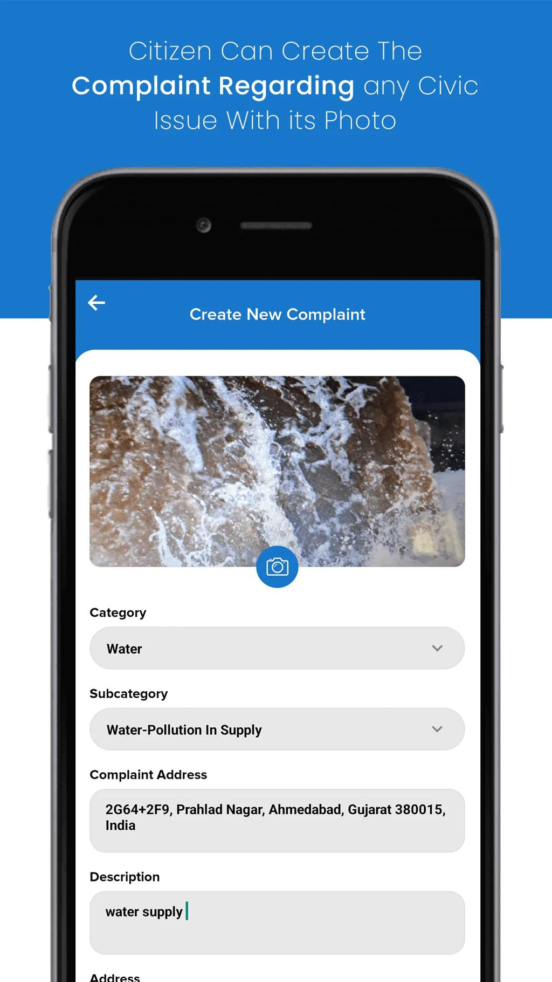
Step 1: Submit a societal challenge
Citizens, NGOs, government bodies, or organizations describe a problem, its location, its impact, and any supporting photos or documents.

Step 2: Discover and evaluate challenges
Students and universities browse the submitted problems, vote on important ones, comment, and propose potential solutions.

Step 3: Collaborate with industry
Companies can provide mentors, technical expertise, datasets, funding, or project opportunities. Teams can request support.
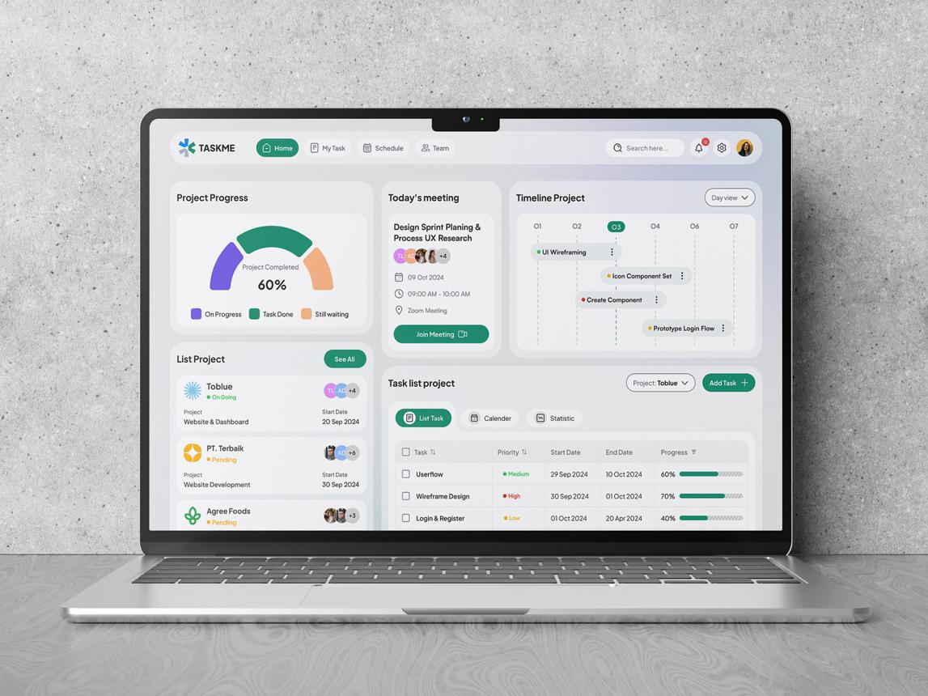
Step 4: Develop and track solutions
Teams submit proposals, track milestones, upload prototypes, and share results. Administrators can review progress and outcomes.

Project division for 6 members
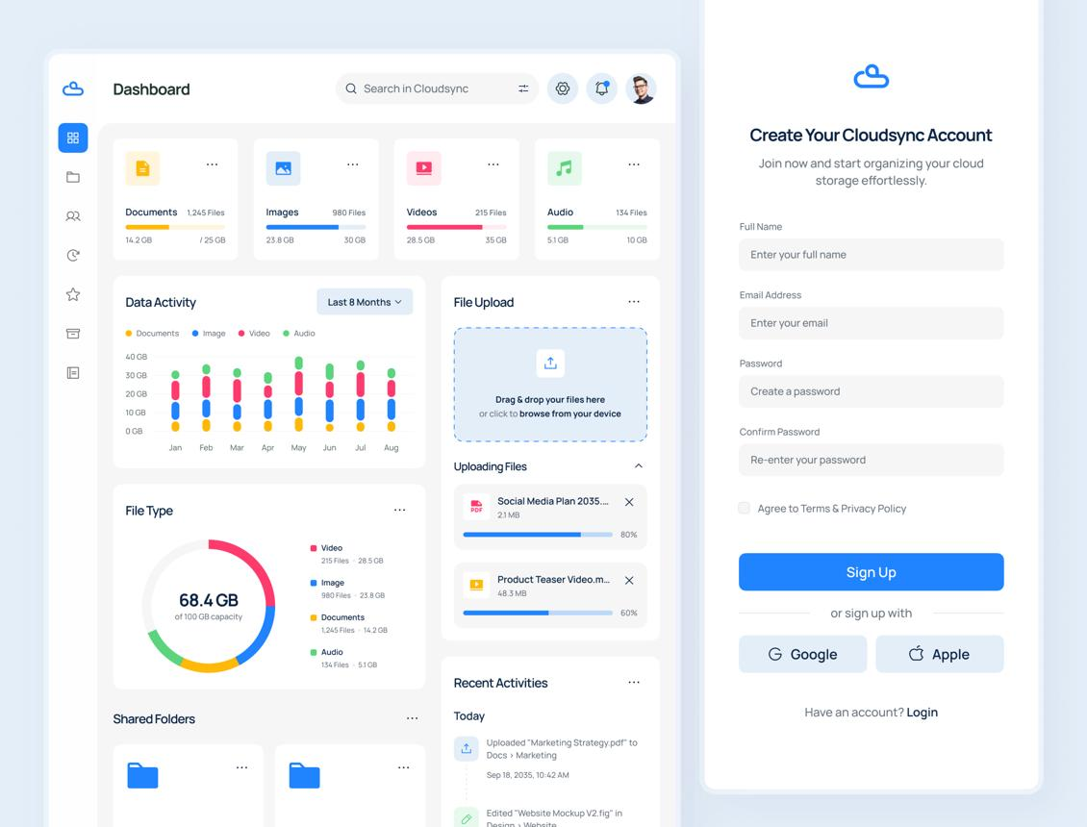
Member 1 — Authentication & User Management
Module 1
Responsibilities
- Registration, login, logout and password reset.
- Role-based access for students, citizens, universities, industry partners and administrators.
- User profiles, skills, interests and organization details.
- Authorization and protected routes.
Deliverable: Authentication system and role-specific dashboards.
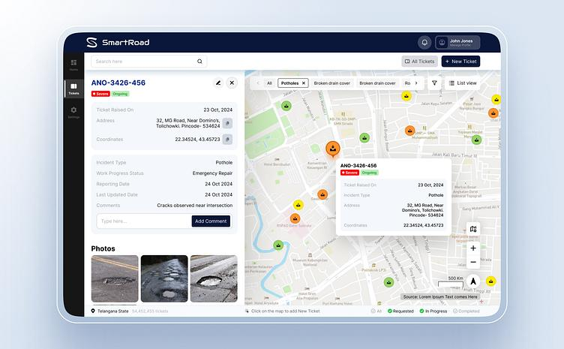
Member 2 — Societal Challenge Management (Trishya)
Module 2
Responsibilities
- Submit challenges with descriptions, categories, locations and attachments.
- Edit, delete and manage submitted challenges according to permissions.
- Categorize challenges such as healthcare, education, agriculture and environment.
- Search, filter, sort and view challenge details.
Deliverable: Complete challenge submission and discovery module.
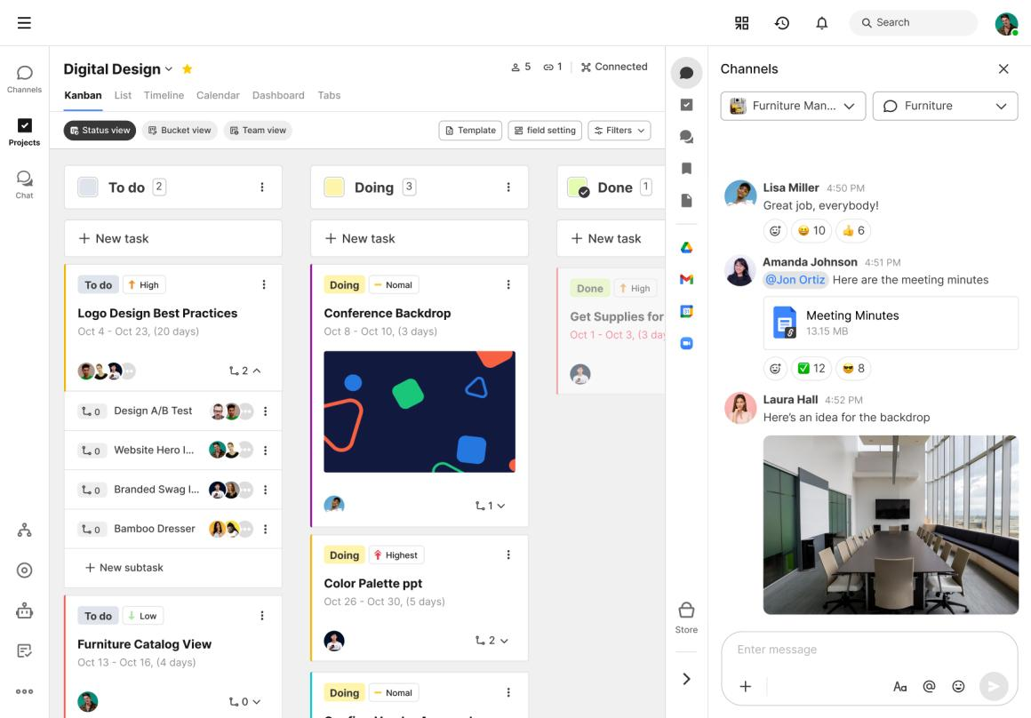
Member 3 — Team Formation & Collaboration (Himanshu)
Module 3
Responsibilities
- Create project teams and invite or accept members.
- Join challenges and form multidisciplinary teams.
- Implement discussions, comments and collaboration notifications.
- Manage team roles, tasks and meeting or milestone updates.
Deliverable: Working team formation and collaboration system.
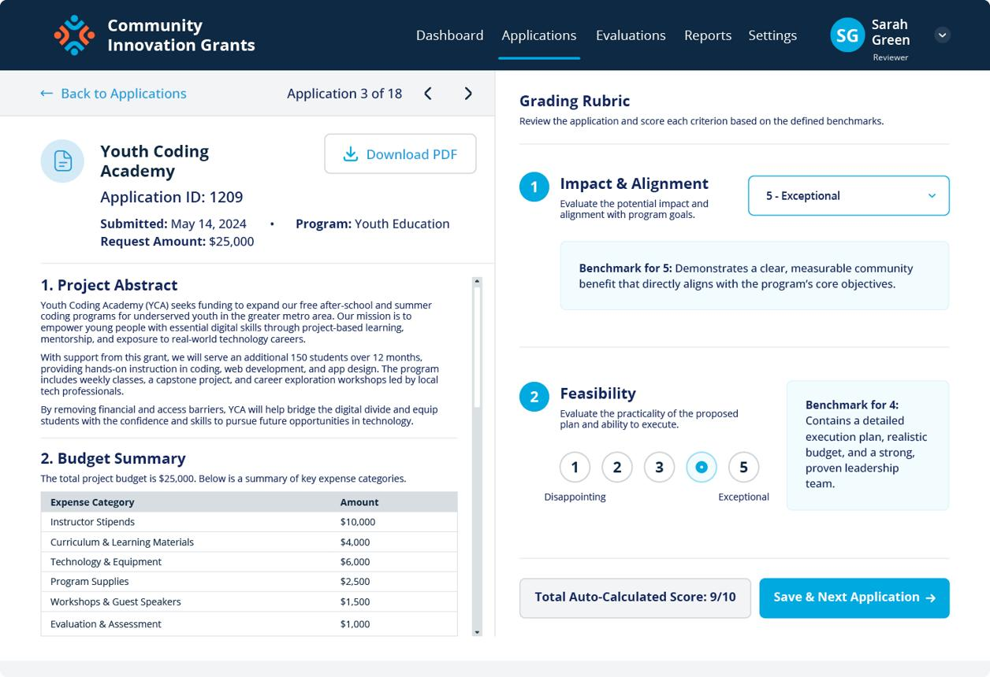
Member 4 — Solution Proposals & Evaluation
Module 4
Responsibilities
- Submit solutions against published challenges.
- Upload prototype links, documents and implementation plans.
- Support proposal reviews, scoring, feedback and approval.
- Track proposal status: submitted, under review, accepted or rejected.
Deliverable: End-to-end solution proposal and review workflow.
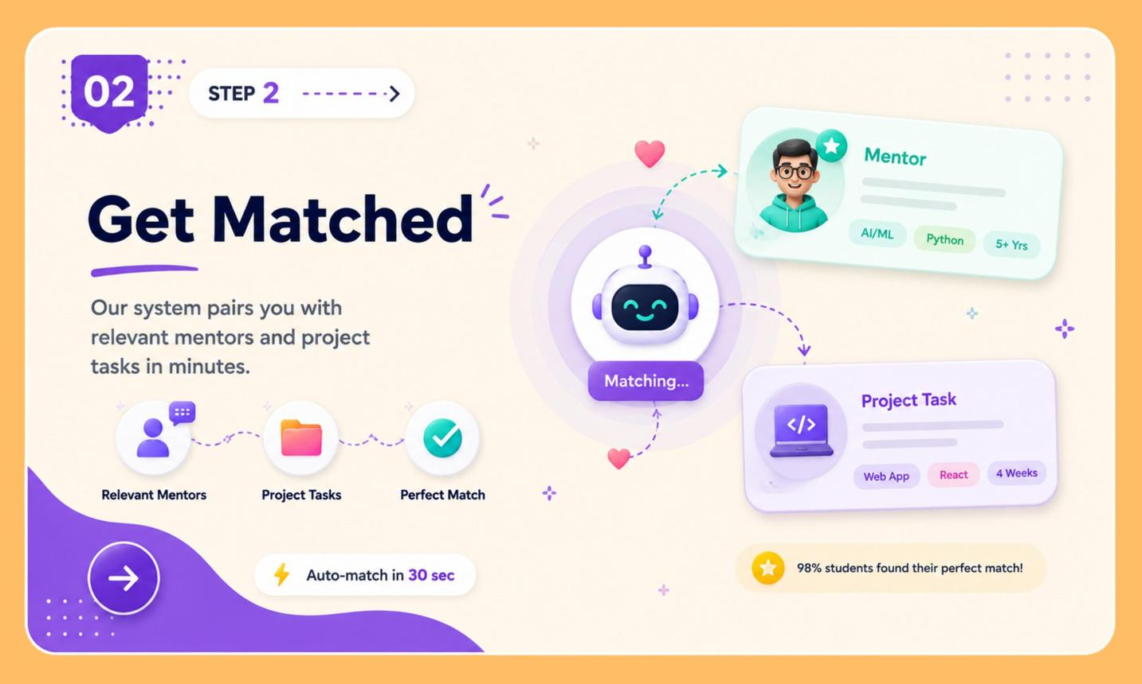
Member 5 — AI-Powered Recommendation Engine
AI Module
Responsibilities
- Detect potentially duplicate or similar challenges using text similarity.
- Recommend relevant challenges based on student skills and interests.
- Match university teams with suitable industry mentors or partners.
- Explain recommendations using skills, categories and relevance scores.
Deliverable: A tested AI recommendation service integrated through backend APIs.
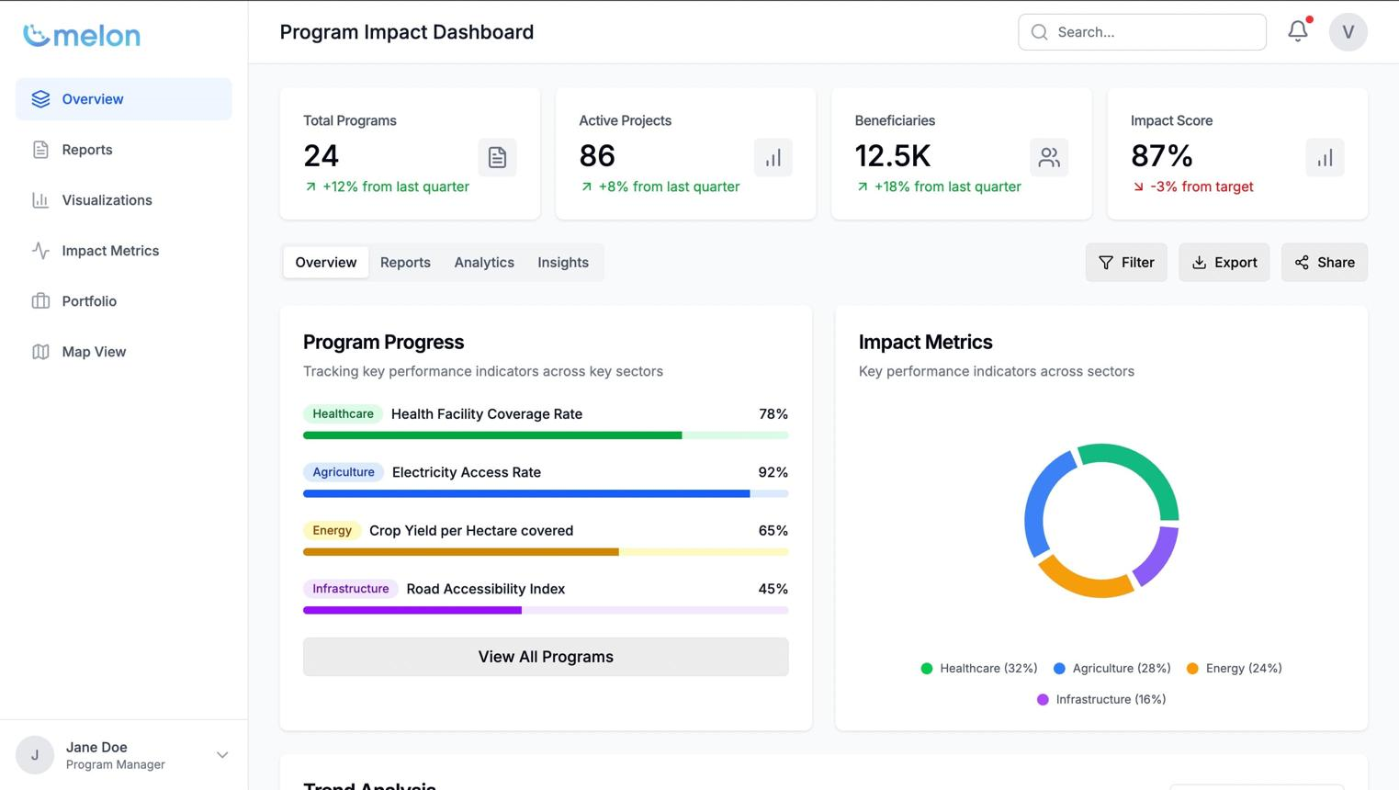
Member 6 — Industry Partnerships, Analytics & Administration
Module 6
Responsibilities
- Manage university and industry organization profiles.
- Allow industry partners to offer mentorship, resources and opportunities.
- Build administrative dashboards for users, challenges and proposals.
- Display analytics such as participation, solution completion and estimated societal impact.
Deliverable: Industry partnership workflow and admin analytics dashboard.

